Project Design Phase-II
Data Flow Diagram & User Stories

Date | 17 January 2026
Team ID
Project Name | A Comprehensive Measure of Well-Being (HDI Tier Prediction System)
Maximum Marks | 4 Marks

Data Flow Diagrams:
A Data Flow Diagram (DFD) is a traditional visual representation of the information flows within a system. A neat and clear DFD can depict the right amount of the system requirement graphically. It shows how data enters and leaves the system, what changes the information, and where data is stored.
Example: DFD Level 0 (Industry Standard)
Example: (Simplified)
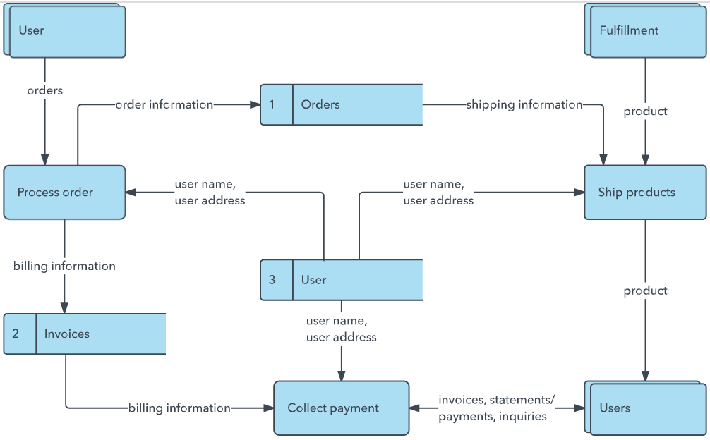


User Stories
Use the below template to list all the user stories for the product.
User Type | Functional Requirement (Epic) | User Story Number | User Story / Task | Acceptance criteria | Priority | Release
End User (Researcher/Student) | Indicator Input | USN-1 | As a user, I can enter life expectancy, mean years of schooling, expected years of schooling and GNI per capita via sliders. | Sliders accept values within realistic UNDP ranges and update a live preview | High | Sprint-4
 |  | USN-2 | As a user, I can submit my indicators and receive a predicted HDI tier with class probabilities. | POST /api/predict returns tier + probabilities within 1 second | High | Sprint-3
 |  | USN-3 | As a user, I can view the exact UNDP formula-based HDI score alongside the ML prediction. | Formula score is displayed and matches manual calculation | High | Sprint-3
 | Visualization | USN-4 | As a user, I can see my result plotted on a well-being spectrum gauge. | Marker position matches the returned tier/score proportionally | Medium | Sprint-4
 | Model Info | USN-5 | As a user, I can view which model is powering the prediction and its accuracy. | GET /api/model-info returns model name and test accuracy | Low | Sprint-3
Developer
Data Scientist
Administrator
Administrator

